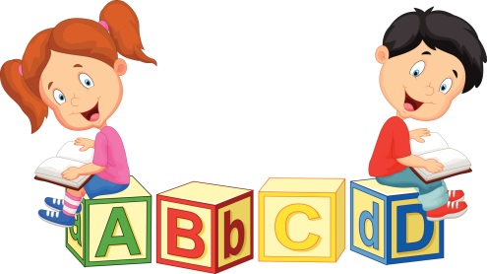
Eastrington Primary School
‘Learning to Read before Reading to Learn’
Dear Parents/Carers,
Over the last term, we have been making some changes to our reading scheme to ensure that the reading books that your child receives offer appropriate challenge, are engaging and phonetically plausible. Early reading is extremely valuable, and it is believed that reading opens the door to your child's early academic success and imparts a love of learning. When children learn to read at an early age, they have greater general knowledge, expand their vocabulary and become more fluent readers; they also have improved attention spans and better concentration.
What does this mean for your child?
We have reorganised our reading scheme in EYFS and KS1 into the Phonic Phases. By doing this, we will be giving your child a greater opportunity to read words using the decoding skills taught in school and which will allow them to develop their fluency and by being able to decode and recognise more words in tier reading books. We strongly believe that this restructure of our reading scheme will allow our readers to read books which are matched to their Phonic Phase and consequently, have a positive impact on your child who should be given the opportunities to develop an enjoyment of reading from an early age.
What do the changes look like?
On your child’s reading book you will notice that there is a white sticker with a number 1-5 written on it, these white stickers simply symbolise the Phonic Phase that your child is being taught. From now, if your child’s book has a numbered white sticker, please ignore the old coloured sticker on the top of your child’s book as this no longer has any relevance to your child’s reading stage.
How do I know what Phonic Phase my child is being taught?
By the end of Reception, most pupils should be able to blend and segment words comprising of sounds from Phase 2 and Phase 3 and recognise the tricky words linked to these Phases.
By the end of Year 1 most pupils should be able to blend and segment words comprising of sounds from Phase 2, 3, 4 ad 5 and read the tricky words linked to these Phases. Pupils should be able to blend ‘real’ and ‘non real’ (pseudo).
Throughout Year 2, pupils learn alternative pronunciation of sounds, they learn the reading and spelling rules for more complex words and we focus further on comprehension, fluency and reasoning skills. Whilst doing this, pupils will become ‘free readers’ and will be assessed within a coloured band and will be encouraged to choose books based on their own interests and enjoyment.

How will this impact my child’s reading development?
By restructuring the books in this way your child will be able to:
- Read books which they can decode
- Feel confident when reading
- Develop a love for reading
- Be exposed to a range of genres
- Become more independent when reading
- Enjoy being questioned about the texts
- Develop comprehension, fluency and reasoning
Where can I find out more?
For further information about how Phonics and English is taught in our school, please see the links which would guide you to our Policy page on our School Website:
http://www.eastringtonprimaryschool.co.uk/wp-content/uploads/2014/12/Phonics-Policy-1.pdf
http://www.eastringtonprimaryschool.co.uk/wp-content/uploads/2014/12/English-Policy-2019.pdf
What can I do to help?
In your child’s book bag you will find a Sound Fan, a relevant Tricky Word Mat and/or a Common Exception Word Mat (Year 1 and Year 2) linked to your child’s Phonic Phase. These resources are for use at home and at school so please keep them in your child’s book bag. The word mats display words commonly found in texts and/or ‘tricky’ words which simply can’t be sounded out and must be recognised by sight. We would like to suggest that you support your child with reading these words just before they read their reading book. Please don’t allow your child to struggle with the reading of any of the words on the cards as these have to be memorised over time.
Please continue to sign in your child’s reading record every time that they read. We would expect that children are reading at home for a minimum of 3 times per week.
If you have any questions, then please don’t hesitate to speak to your child’s class teacher.
Kind Regards,
Mrs Kay (Phonics Coordinator) and Mrs Hardcastle (English Coordinator)

